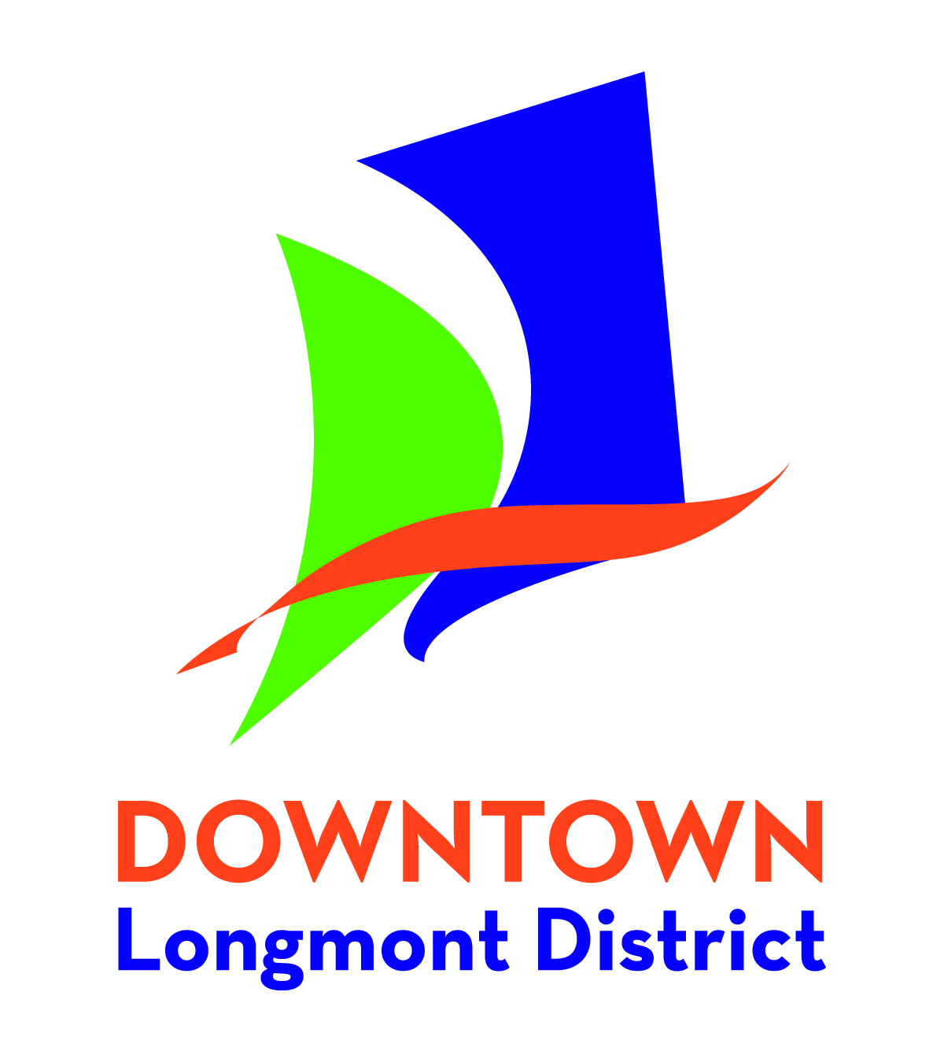
Longmont Downtown Development Authority
Volunteer Acknowledgment of Risk and Release
528 Main St., Longmont, CO 80501 303-651-8484

I, the undersigned, agree for myself or for my minor child, to volunteer for Longmont Downtown Development Authority, and understand and agree to the following

- I will follow instructions of my placement and perform my service to the best of my ability.
- I acknowledge that there are dangers and risks incurred as a result of participating in activities connected or associated with volunteering; and I knowingly assume all risk for any injuries, death, damage or loss to my person, including but not limited to: falling down, tripping, bumping; back, bone, joint, head, neck, muscle or spinal injuries or strains; cuts, scrapes; choking; allergies; heat stroke, heat exhaustion, sunburn or other injuries; and/or any damage or loss sustained to my property.
- In the event of any emergency, I authorize Longmont Downtown Development Authority officials to secure from any licensed hospital, physician and/or medical personnel any treatment deemed necessary for my immediate care, including ambulance transport. Further, I agree that I will be responsible for payment of any and all medical services rendered.
- I waive and relinquish all claims I may have as a result of my participation as a volunteer against the Longmont Downtown Development Authority and its officers, agents, servants and employees.
- I act only as a civilian volunteer and do not function as an employee, agent or representative of the Longmont Downtown Development Authority.
- I give permission for media coverage of myself and/or my minor child to be disseminated for public relations purposes. (CROSS OUT if you do not give this permission)
- This Acknowledgement of Risk and Release is valid for a period of 5 years from the date executed below.
- I give permission for my name and address to be shared with other volunteer organizations. (CROSS OUT if you do not give this permission)

While serving as an Authorized Volunteer for the benefit of and involved in the activities at the request of the Longmont Downtown Development Authority volunteers are provided the protection of the Colorado Governmental Immunity Act Section 24-10-101 (et_ seq.) and are subject to the applicable provisions of the Act. The Act does not cover any willful and/or wanton behavior including, but not limited to, sexual harassment, racial or gender discrimination, drug and/or alcohol use.

I acknowledge and understand the Longmont Downtown Development Authority risk and release. This acknowledgment of risk and release shall not be modified orally. All minor's signature (under 18 years of age) must be accompanied by the signature of the parent or guardian.

Date:

Print Volunteer Name: Signature:

Print Volunteer Name: Signature:
(parent/guardian if under 18 years old)

Emergency Contact: Phone #:

