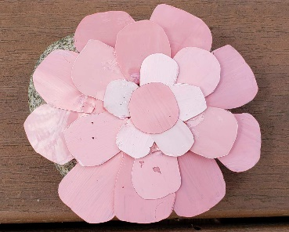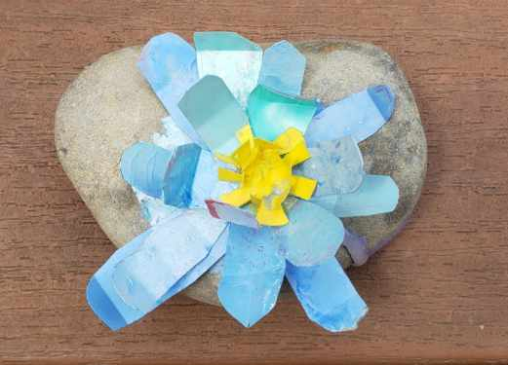

3D Rock Painting Materials

Materials (look at the pictures for more information)

* Rock
* Plastic
* Marker
* Pallet
* Paper towel
* Acrylic paints
* Thick paint brush

* Scissors
* Cup of water
* Hot glue

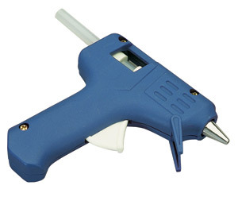

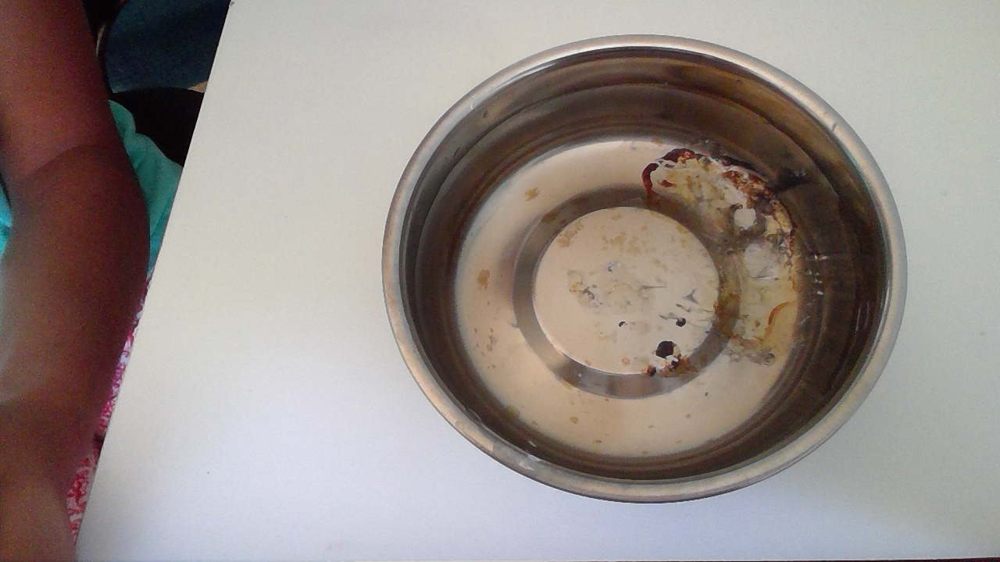

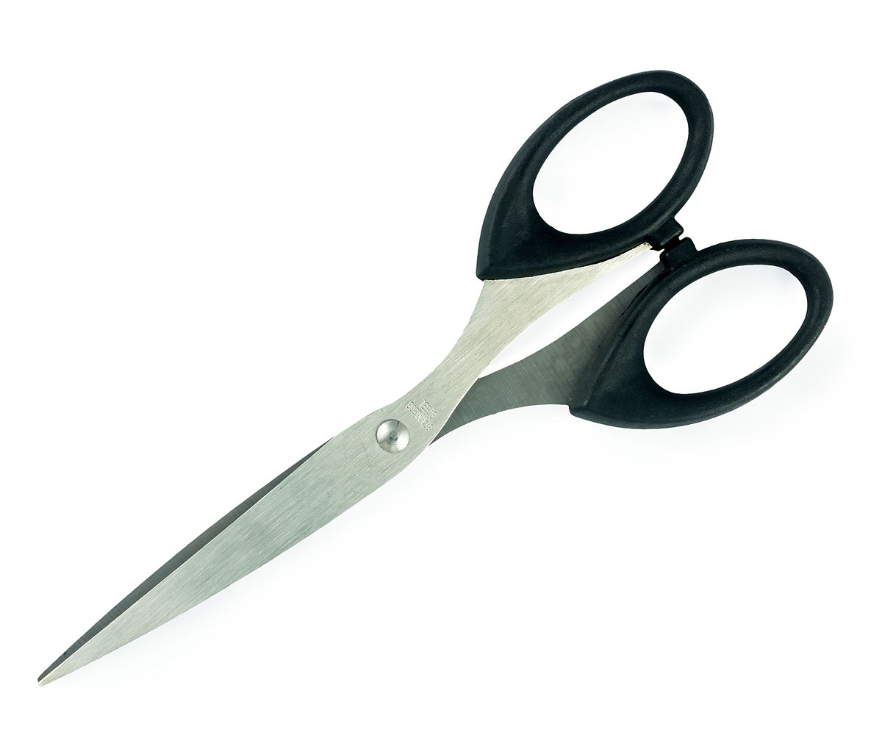

Water

Scissors to cut the plastic.

A cup of water, to clean your brush.

Hot Glue with at least 2 hot glue sticks.

Picking the perfect rock: you need a wide rock for the big center of the flower, big height for your flowers petals to spread out, big enough to make a flower with lots of petals, and a flat rock at the bottom so its easier to paint.

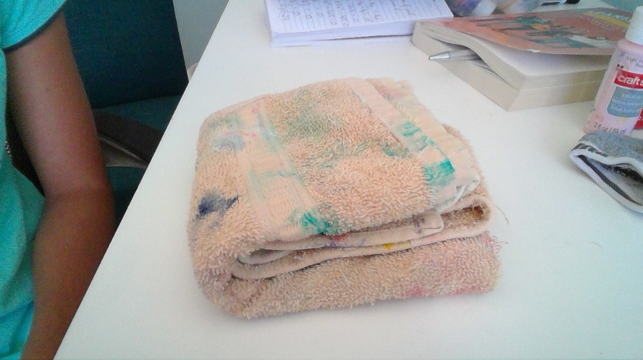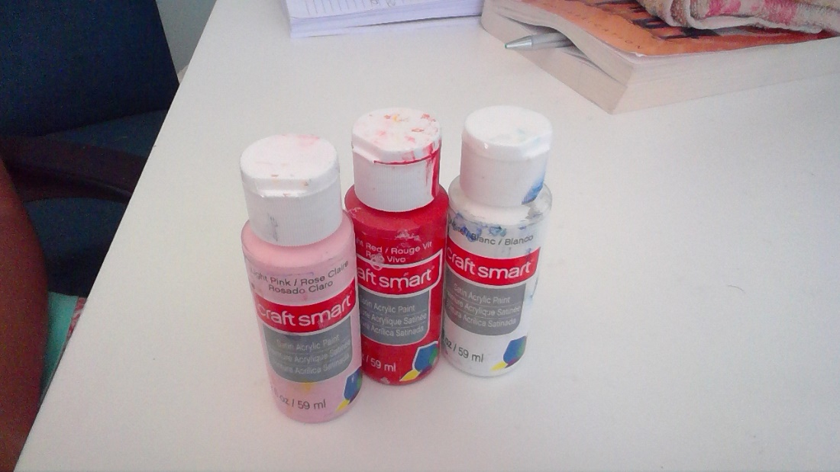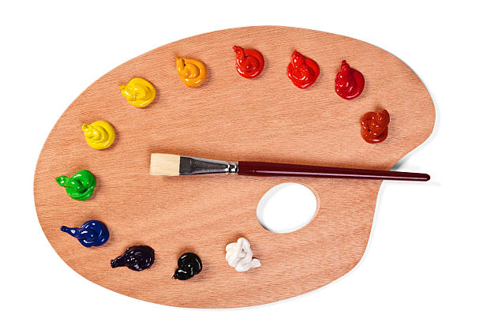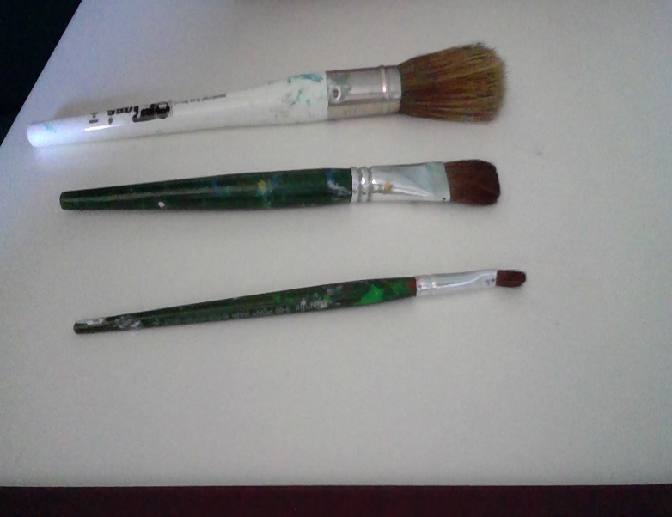

A towel to dry your brush, a paper towel works well too.

A paint pallet to mix and hold you paints.

Acrylic Paints in the colors pink, red and white(Optional yellow and any other colors if you don’t want a pink flower.

This shows a type of marker you can have, you can use sharpies, Crayola Markers, washable markers, and highlighters etc. The point is to have something the makes thick lines.

This picture shows the different thicknesses paint brushes come in. You want to pick the paint brush in the middle, it is not too thick but not too thin.

You can get this type of sturdy, thin, and flexible plastic in spinach, and strawberry boxes, and one-time use plastic water bottles.