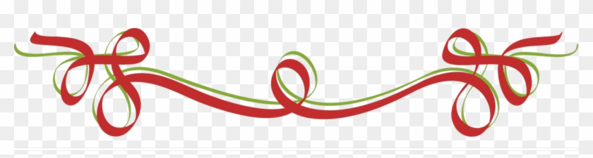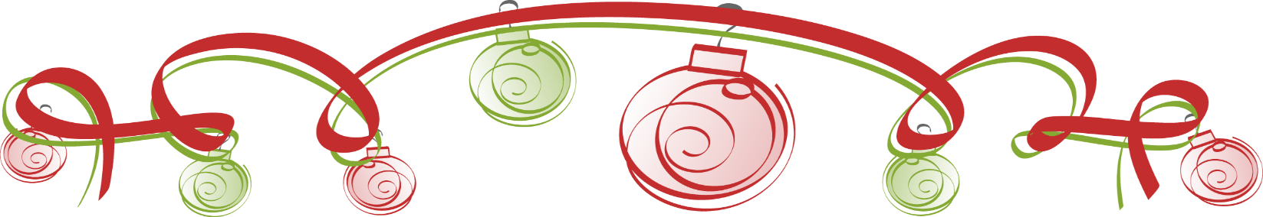

**ST. FRANCIS**

**MOTHERS’ GUILD**

**ANNOUNCES OUR**

2022

KNIGHTWEAR

HOLIDAY SALE

Date: December 5th and 6th

Time: 11:45 am to 12:10 pm

Where: On campus/quad

Get ready for the holidays with St. Francis merchandise! We will be

*on campus for two consecutive days.* Your sons can purchase licenses frames, sweatshirts,

t-shirts, windbreakers, jewelry and other stocking

stuffers for the entire family.