**JOIN Tau Epsilon Omega (Alpha Kappa Alpha) FOR A VOLUNTEER DAY WITH JA of Georgia!**

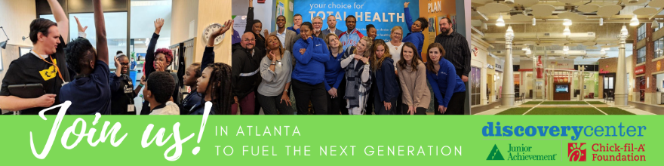

*Every child has a dream, a vision for what their future can be. Our mission is to provide students with opportunities to make those dreams a reality for middle school students; an immersive simulation that enables them to develop skills to successfully navigate today’s complex economic environment and discover how decisions today can impact tomorrow. Our two programs at our JA Discovery Centers are: JA BizTown & JA Finance Park.*

**When?** **Thurs, December 6th - 8am-2:45pm**

**Where?** Downtown Atlanta | [JA Chick-fil-A Foundation Discovery Center](https://www.georgia.ja.org/ja-discovery-center-atlanta)

**Why we need coaches?** Adult stories bring the simulation to life for the students, by sharing real life experiences while coaching a small group of students.  Our volunteers provide those "ah ha" moments daily as they help students discover the value of themselves, their education, and their future possibilities! Check out of [Volunteer Video](https://www.youtube.com/watch?v=QuXefjwq_kA) to see a preview of the day.

\***Day-of training, parking, coffee, and lunch provided to all volunteers.**

**Questions about the day?**Reach out to Andrea [AGill@georgia.ja.org](mailto:AGill@georgia.ja.org)

**How do I sign-up?** See more details and sign-up with this [**Registration Link**](https://jageorgia.volunteerhub.com/lp/aka/event/385102b2-f34e-43b7-90d1-5981fd88fb98)or via the**QR Code below**



*Hover Device camera over QR code for link