**Warmer**: Highs and lows

* Greet the kids and ask them how their day/ week has been.
* Ask the students what their school Highs are for the day or week?
* After all the kids have shared, ask all the kids what was a school low for the week.

**Homework help**: Ask the students to share their screen and show you what they are working on. If you are having trouble getting the students to share below are some questions you can ask to stimulate the conversation on what they are learning and what they may need help on.

Ask questions like:

* What homework did you have this week?
* Can you show me you English/math/ history…?
* Can you tell me about what you did in history/English/ math/ science this week?
  + Can you explain it to me?

**SILLY NAMR break:** What is your unicorn name? This one is silly and the boys might not like it but encourage them to do it. Encourage the kids to change their zoom names to their new unicorn names.

**Review**: Fractions <https://www.khanacademy.org/math/cc-fifth-grade-math/imp-fractions-3/imp-visually-adding-and-subtracting-fractions-with-unlike-denominators/v/visually-adding-fractions-with-unlike-denominators>

* Adding and subtracting fractions: <https://youtu.be/fvtv2uYjo_E> 
  + **Practice:** [**https://www.khanacademy.org/math/cc-fifth-grade-math/imp-fractions-3/imp-visually-adding-and-subtracting-fractions-with-unlike-denominators/e/using-visuals-to-add-and-subtract-fractions-with-unlike-denominators-?modal=1**](https://www.khanacademy.org/math/cc-fifth-grade-math/imp-fractions-3/imp-visually-adding-and-subtracting-fractions-with-unlike-denominators/e/using-visuals-to-add-and-subtract-fractions-with-unlike-denominators-?modal=1)
* If the kids are grasping it try working on estimating fractions: <https://youtu.be/XR_B9AJe1u4>
  + **Practice:** [**https://www.khanacademy.org/math/cc-fifth-grade-math/imp-fractions-3/imp-visually-adding-and-subtracting-fractions-with-unlike-denominators/e/estimate-to-add-and-subtract-fractions-with-different-denominators?modal=1**](https://www.khanacademy.org/math/cc-fifth-grade-math/imp-fractions-3/imp-visually-adding-and-subtracting-fractions-with-unlike-denominators/e/estimate-to-add-and-subtract-fractions-with-different-denominators?modal=1)

**KAHOOT!** [**https://kahoot.it/challenge/05330862?challenge-id=e21d906a-1678-4c6e-a9ee-5f26c1dc0f29_1614965677932**](https://kahoot.it/challenge/05330862?challenge-id=e21d906a-1678-4c6e-a9ee-5f26c1dc0f29_1614965677932) **Game ID: 05330862**

* **If the kids can log in let them play on their own computer on tablet while you share screen.**

**Games**:

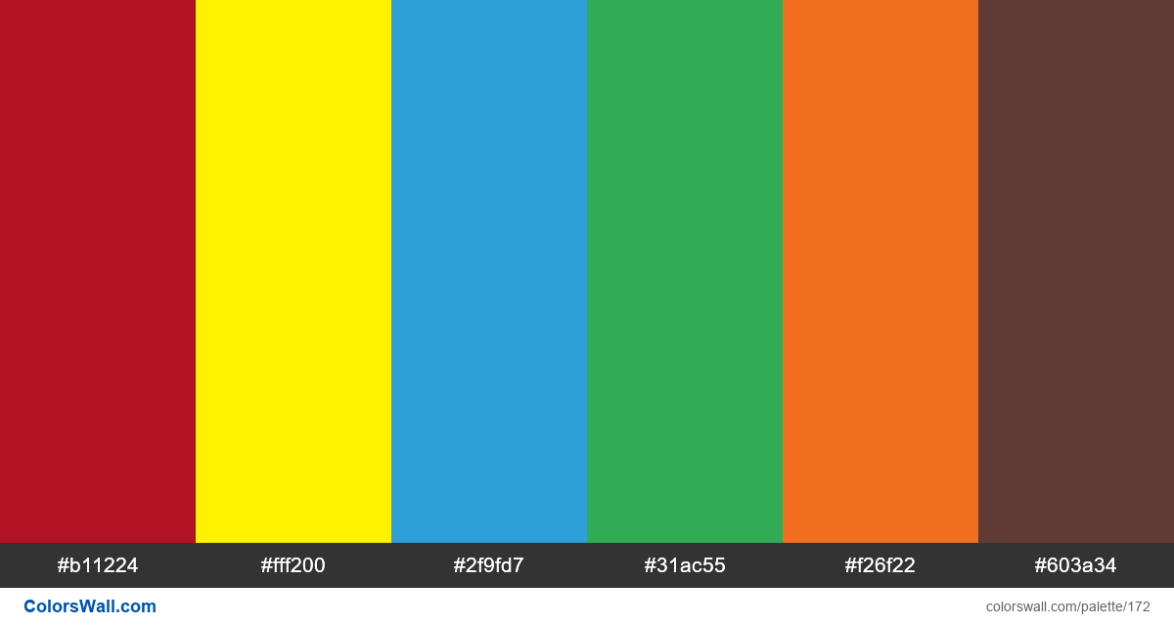**Pick a color**: this game is normally played with M&Ms but because we are virtual I have adapted it to our context.

1. Share the picture with the students. Ask the students to pick a color and write it in the chat.
2. Coaches then tell the kids that each color is going to be a challenge.
3. Based on the colors the kids put in the chat take turns asking the kids to do the challenges that correlate to the colors. Feel free to change the questions or challenges if you want.
   1. Red: What is your favorite animal? OR Do 3 pushups.
   2. Yellow: How many brothers and sisters do you have? OR get 1 of you siblings and have them say Hello on zoom.
   3. Blue: What is your favorite food? OR Run and get a spoon and show it to the camera.
   4. Green: What do you like to do for fun? OR Show us your favorite toy.
   5. Orange: What is your teacher’s name? OR Dance for 5 seconds.
   6. Brown: What is your favorite movie? OR Make a silly face.

**Wrap up** finish working on what you are working on or transition to the game.