

DIY WATERCOLOR PAPER LANTERN TUTORIAL AND PATTERN
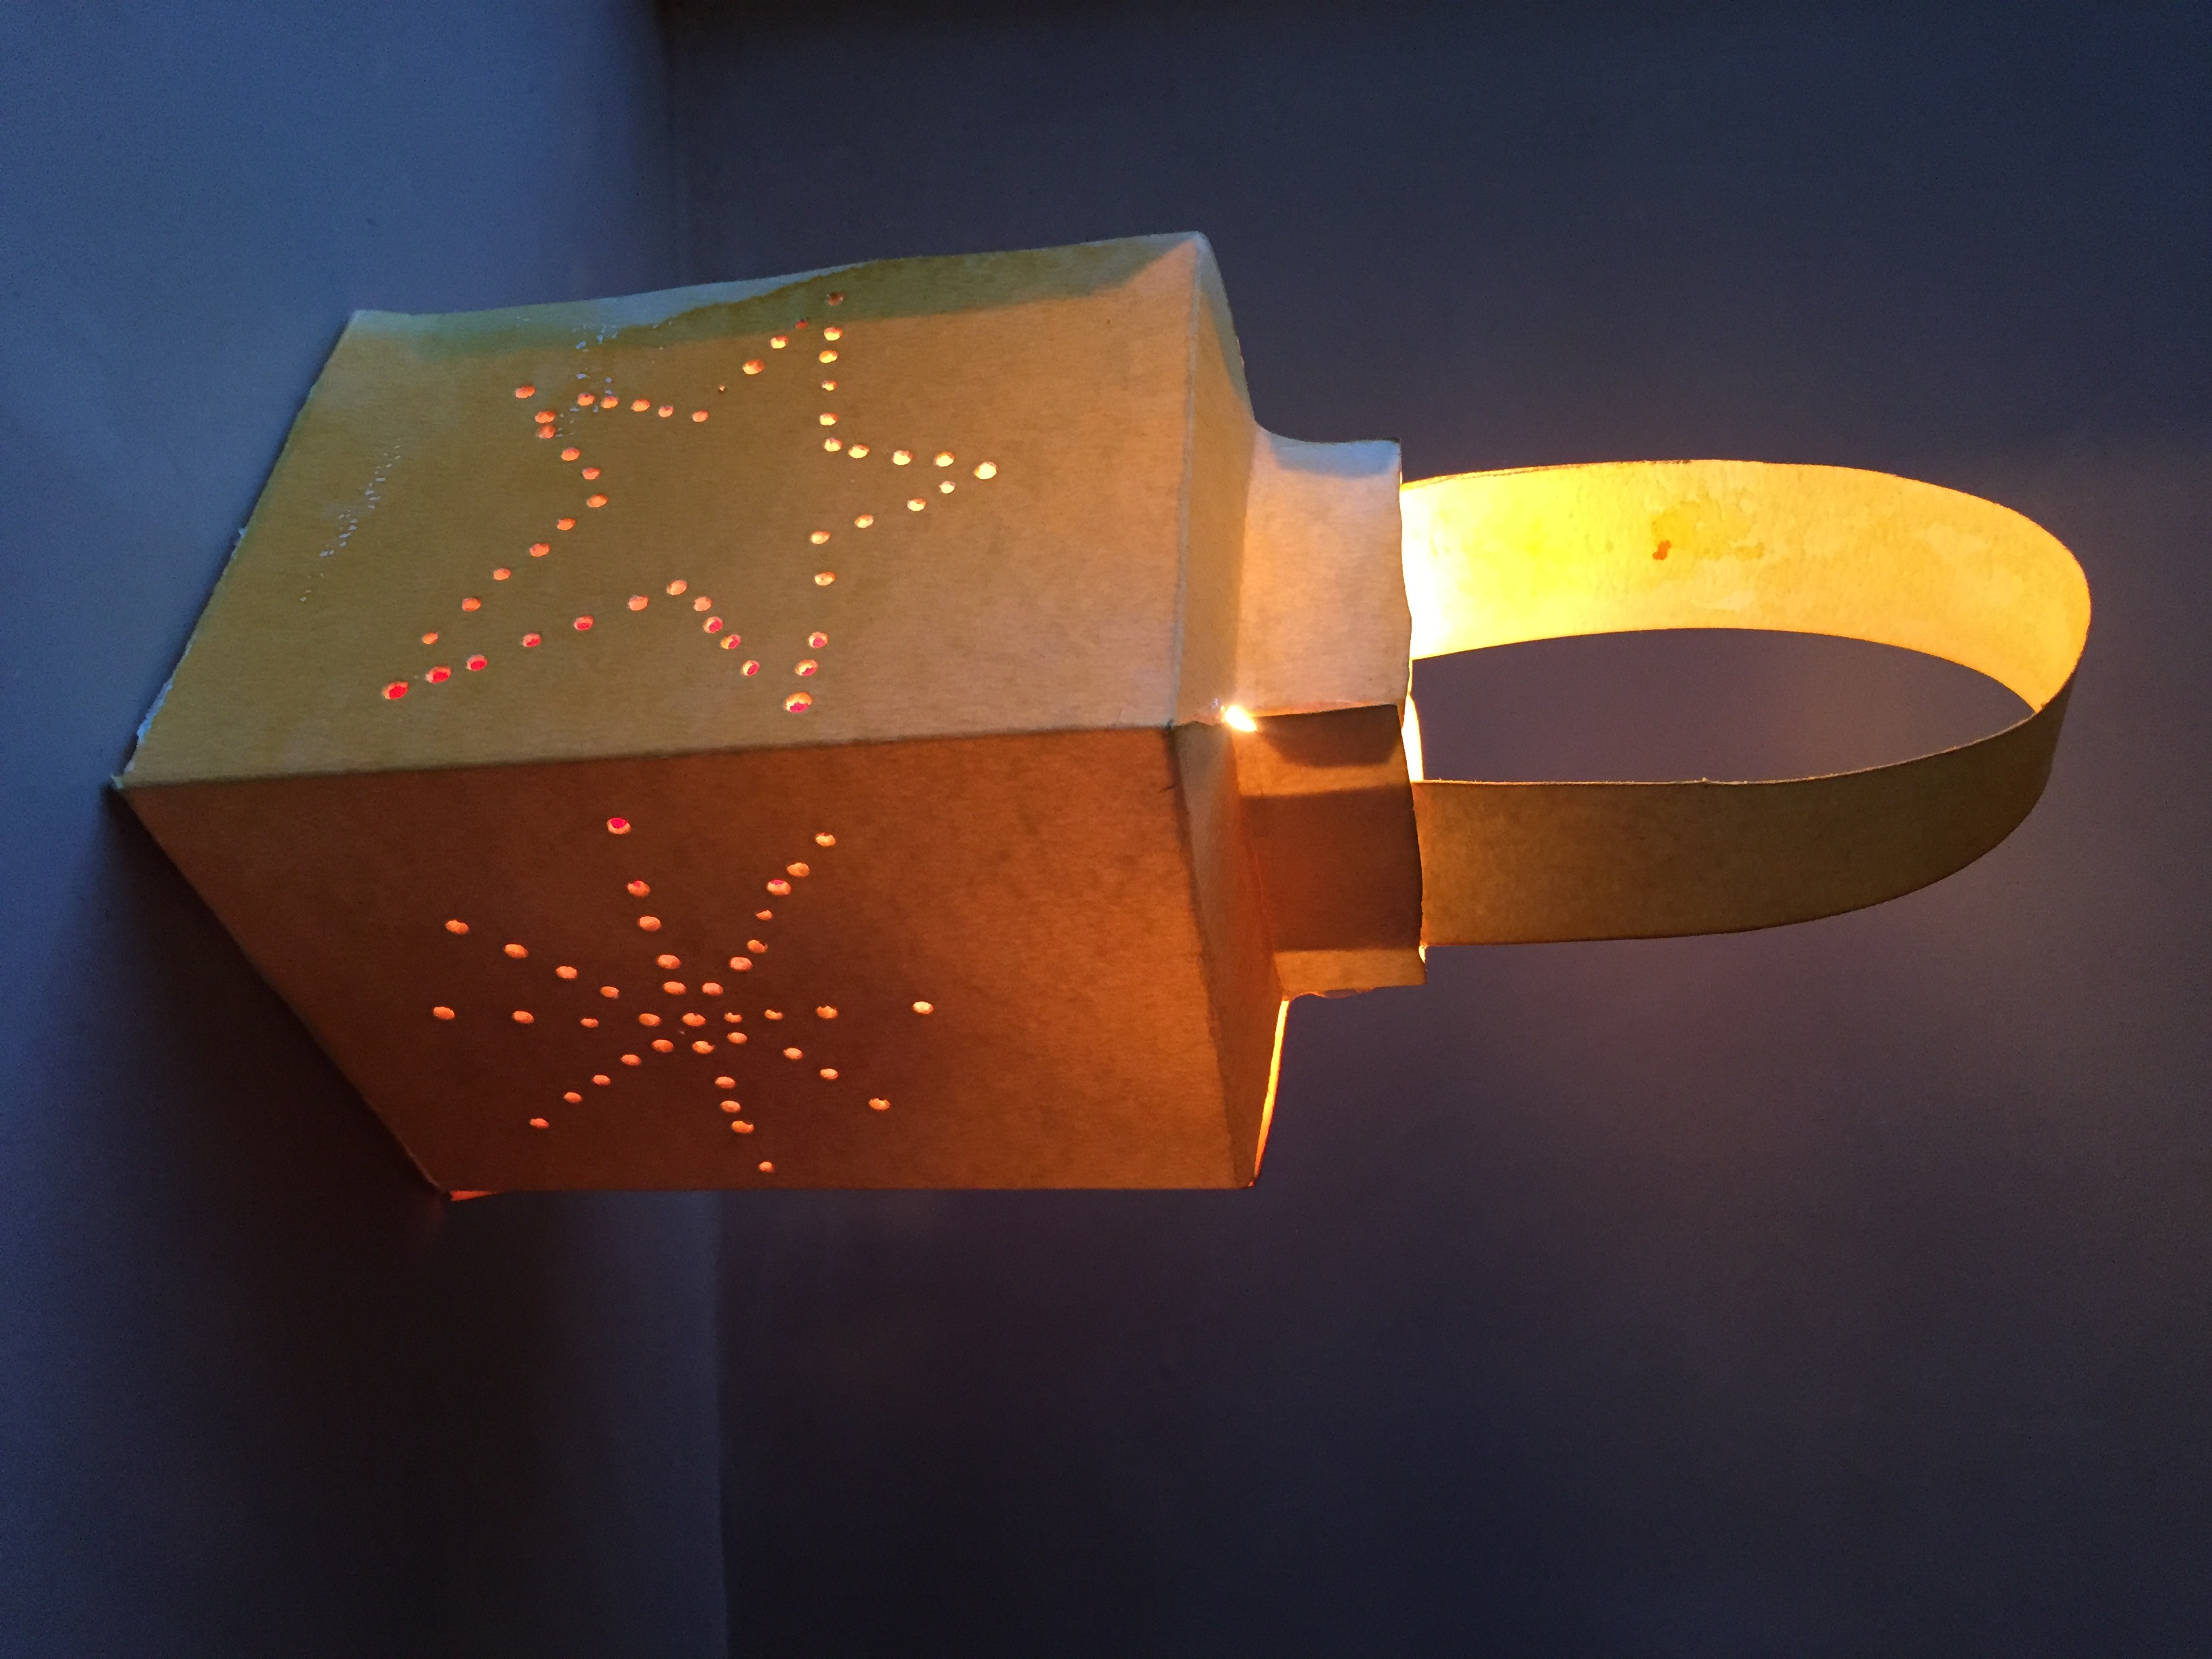

Materials:
- 2 sheets of 11 x 14” heavy watercolor paper OR 3 sheets of 8.5 x 11” heavy watercolor paper
- Watercolor paint
- Scissors
- Hot glue gun and glue sticks, paste, or super glue
- Ruler or straight edge
- Piece of foam or similar material
- Push pins or something similar for poking small holes (optional)
- Ice pick or something for poking large holes (optional)

Instructions:
Use either 2 sheets of 11 x 14” OR 3 sheets of 8.5 x 11” heavy watercolor paper. Soak the paper in water for a few minutes and then use a “wet-on-wet” technique to paint the watercolor, or simply paint them with any watercolor technique. Let paper dry completely.

Print the PDF pattern, it is two pages long. Cut out the pattern on the dotted lines. Trace the pattern onto the back sides of your dry watercolor paper. Cut out the traced pattern. The pieces will look like this.

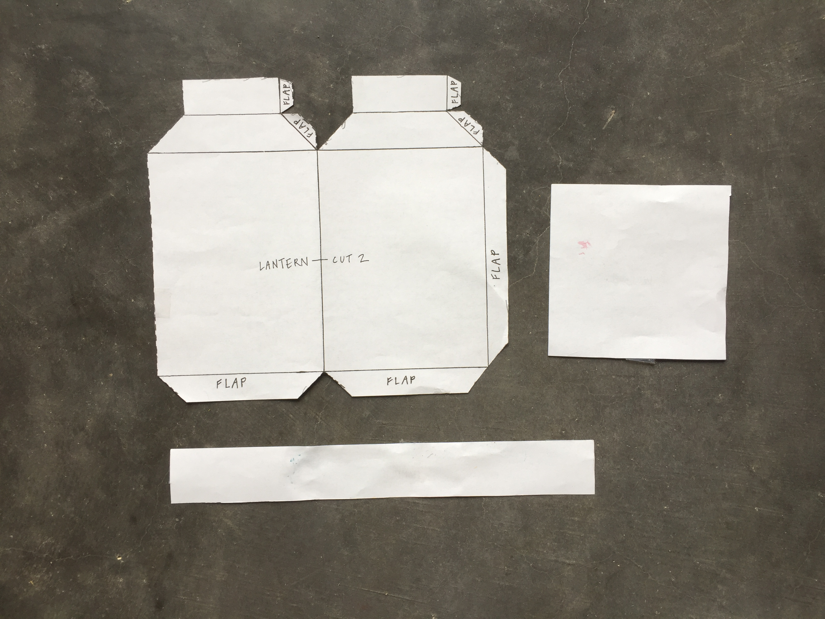
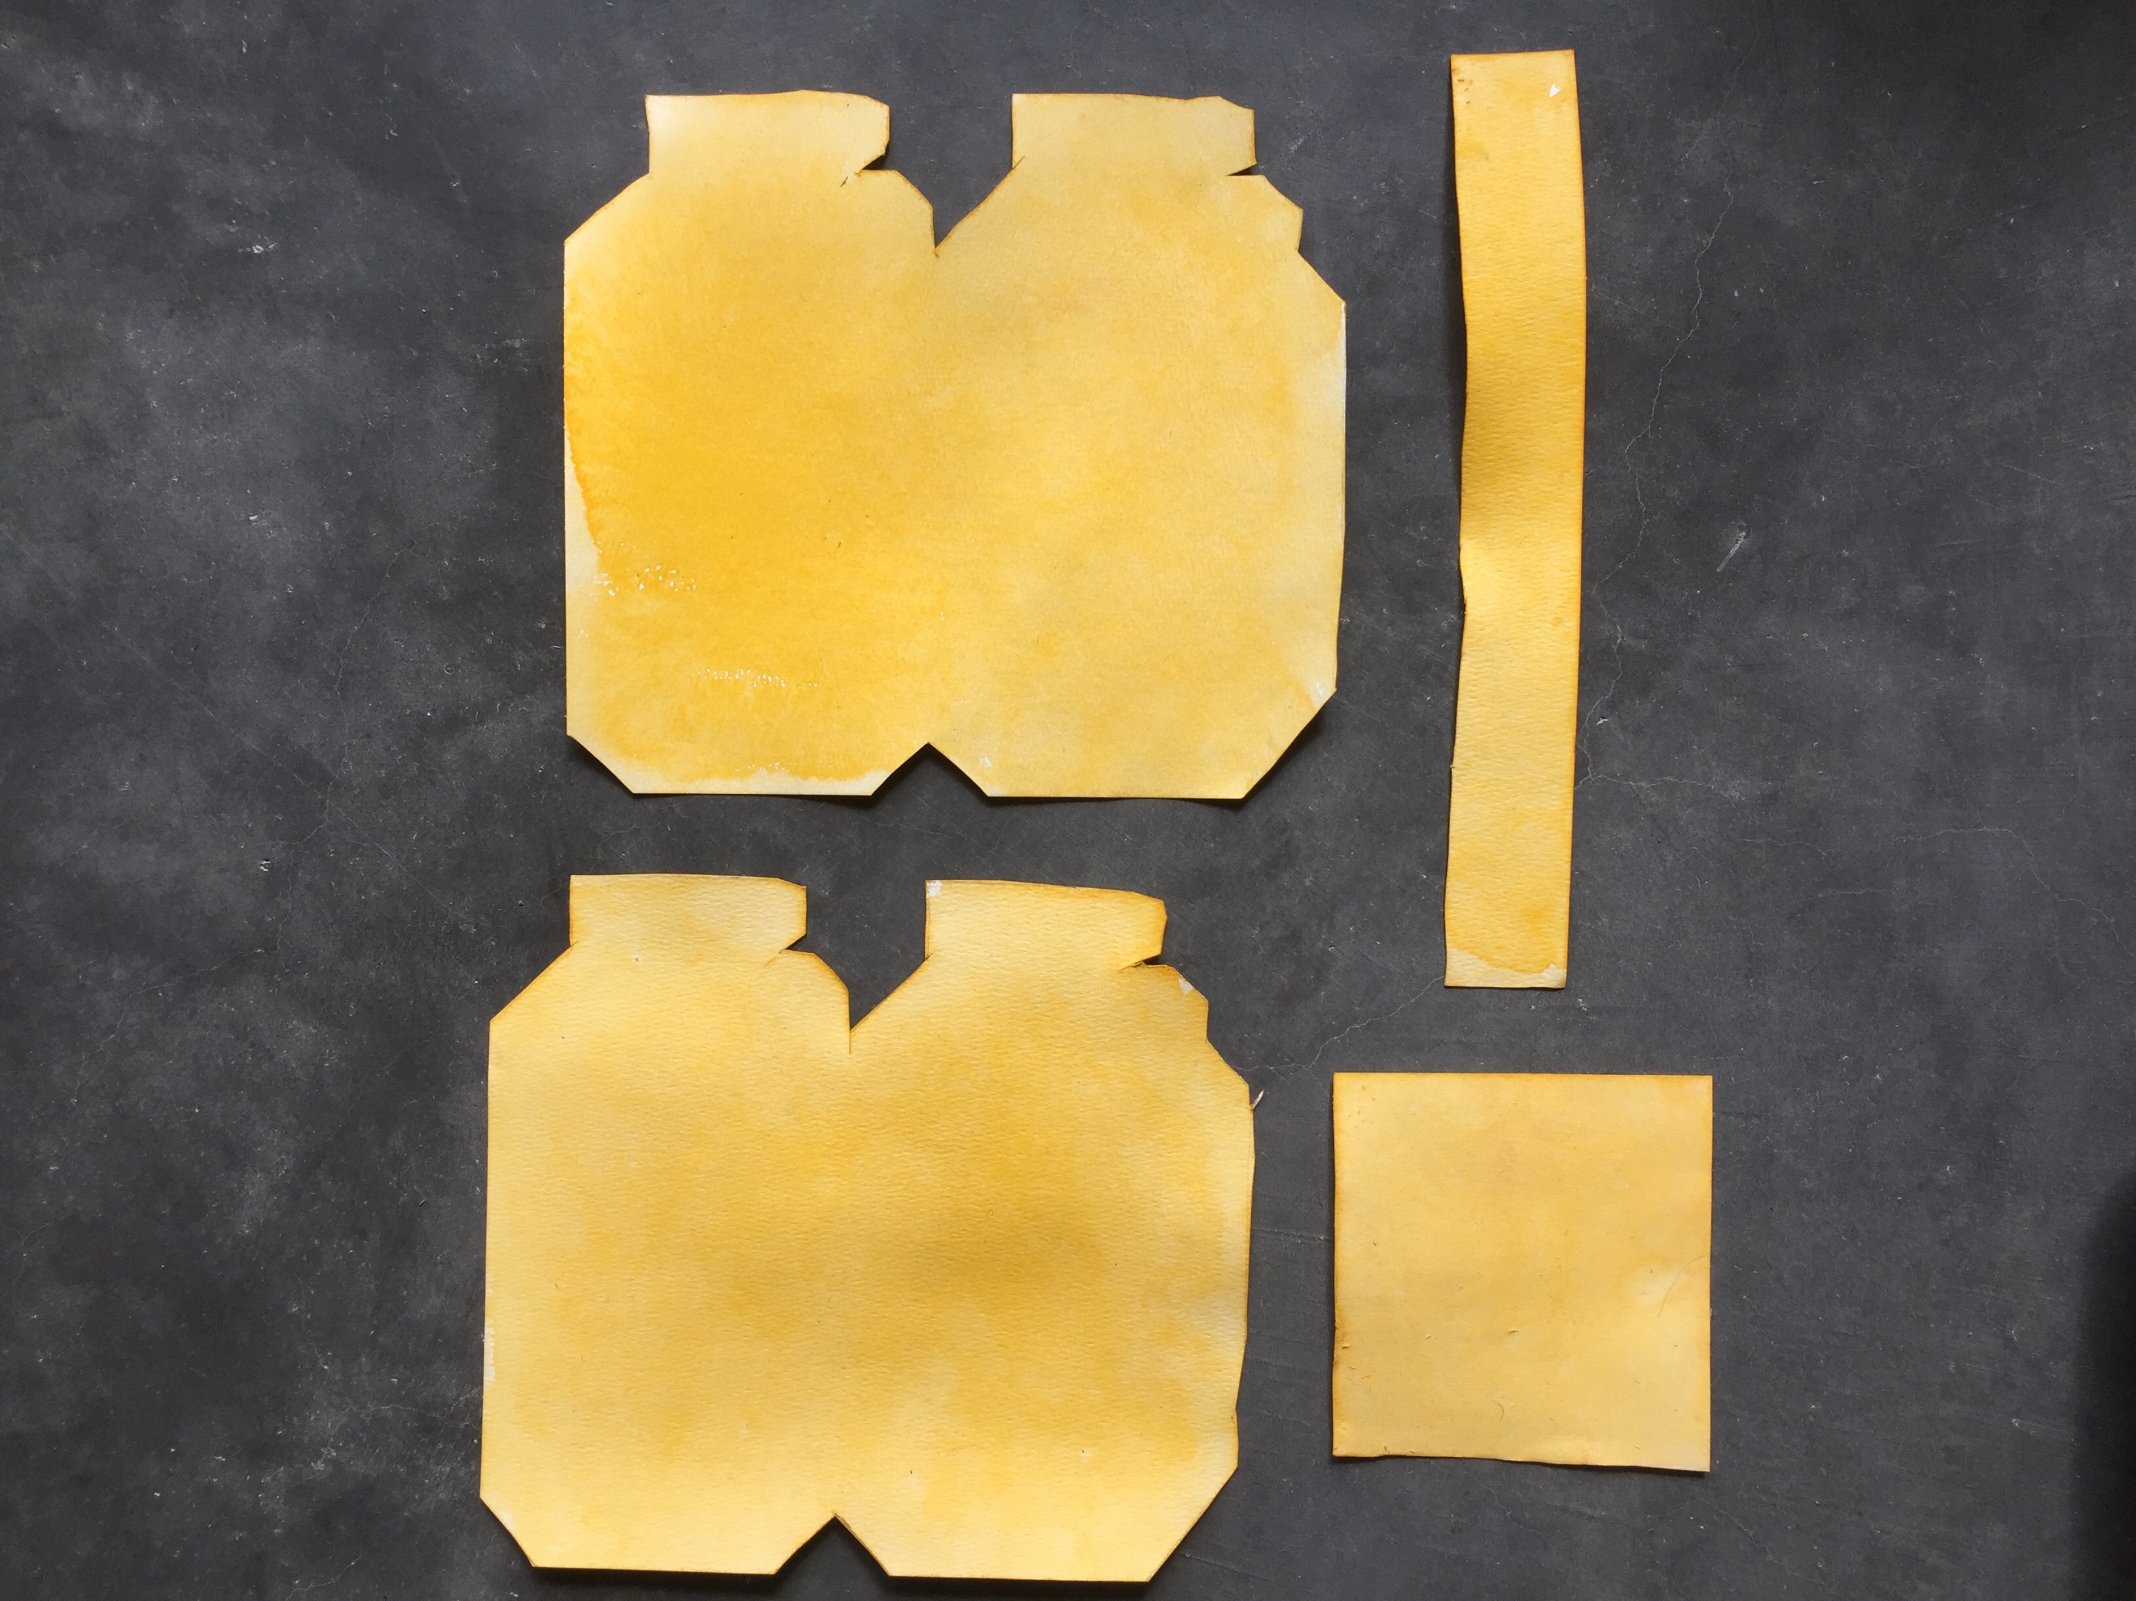

If you wish draw the fold lines onto the back side of your cut watercolor paper pattern, as the lines appear on the pattern. Or, if you’re like me, you can just guess where those fold lines are, based on the pattern you cut out. Then use a straight edge to fold on the fold lines.
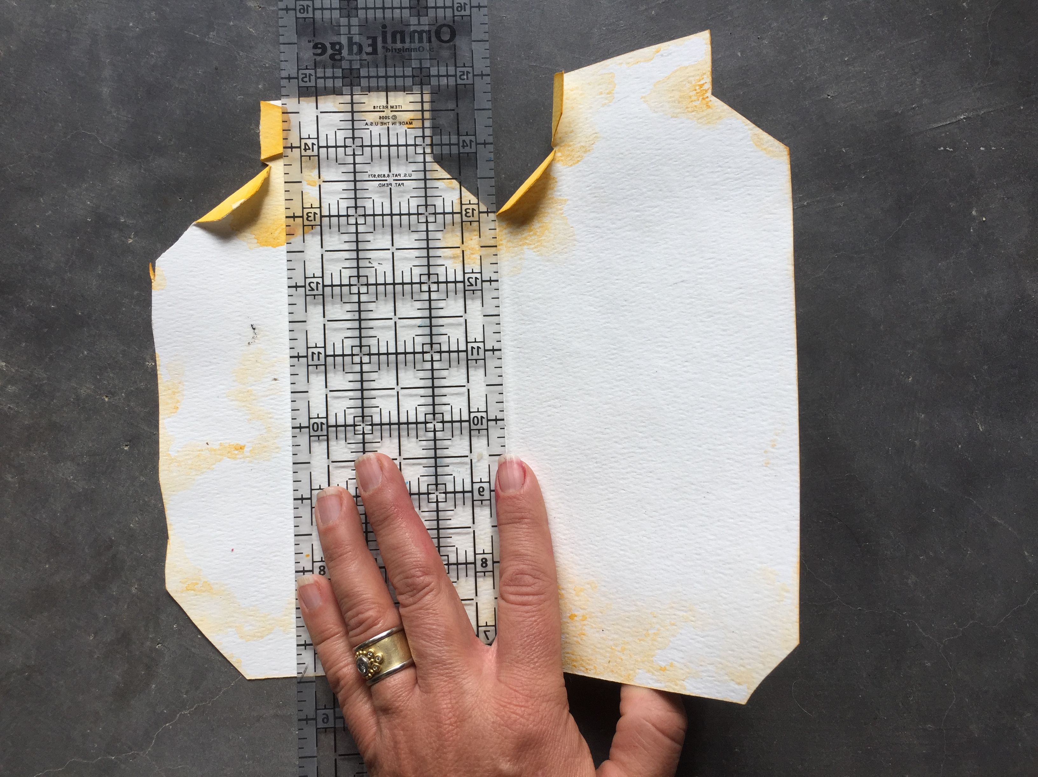

Next, draw your own light hole patterns/designs on the back sides of the watercolor cut-outs. You could draw a star, or a moon, or anything you like. Then make little pricked light holes by first punching small holes in the back side of your watercolor paper cut-outs. Next turn over to the right sides over the cut-outs and use an ice pick to make the holes bigger. To do this, first put a piece of foam under the paper, and a cutting board under the foam.
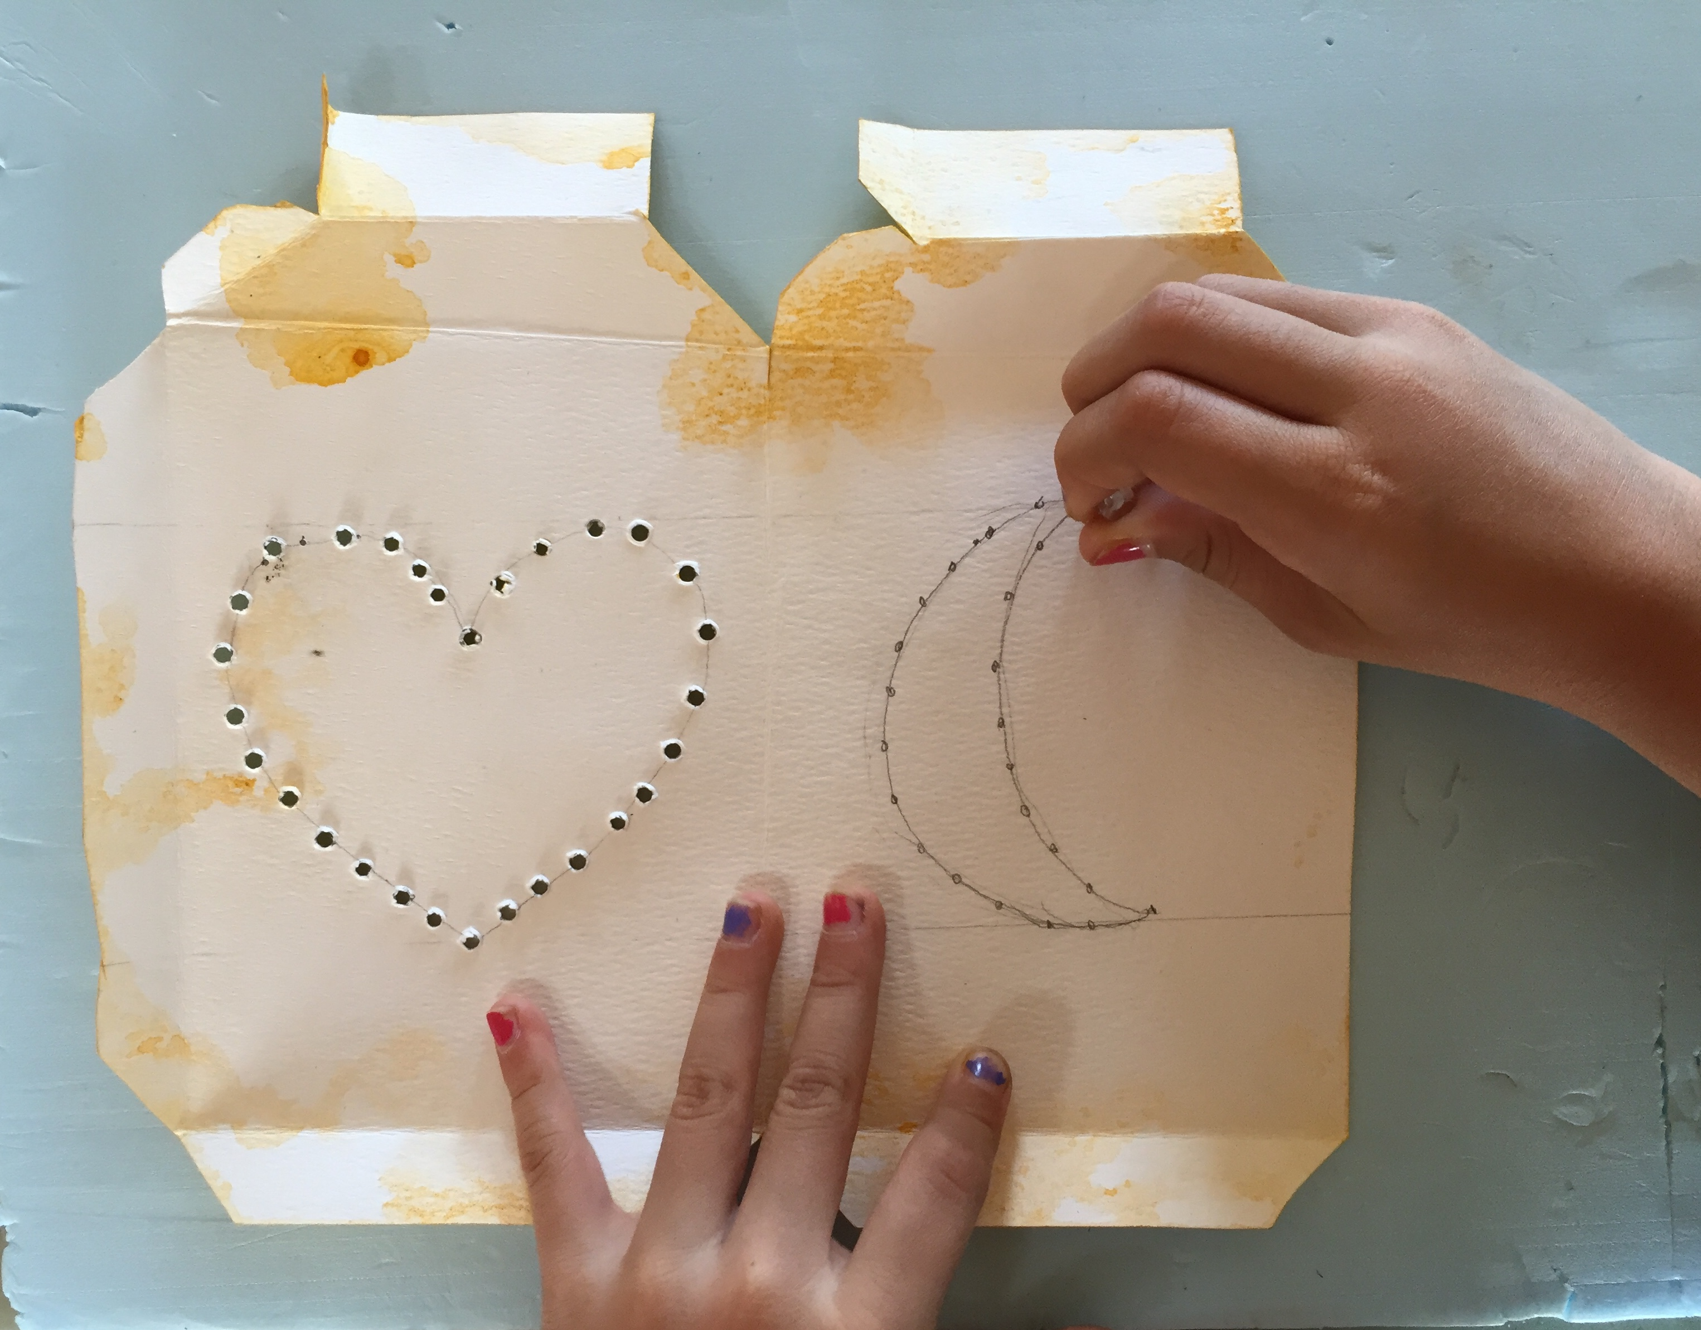

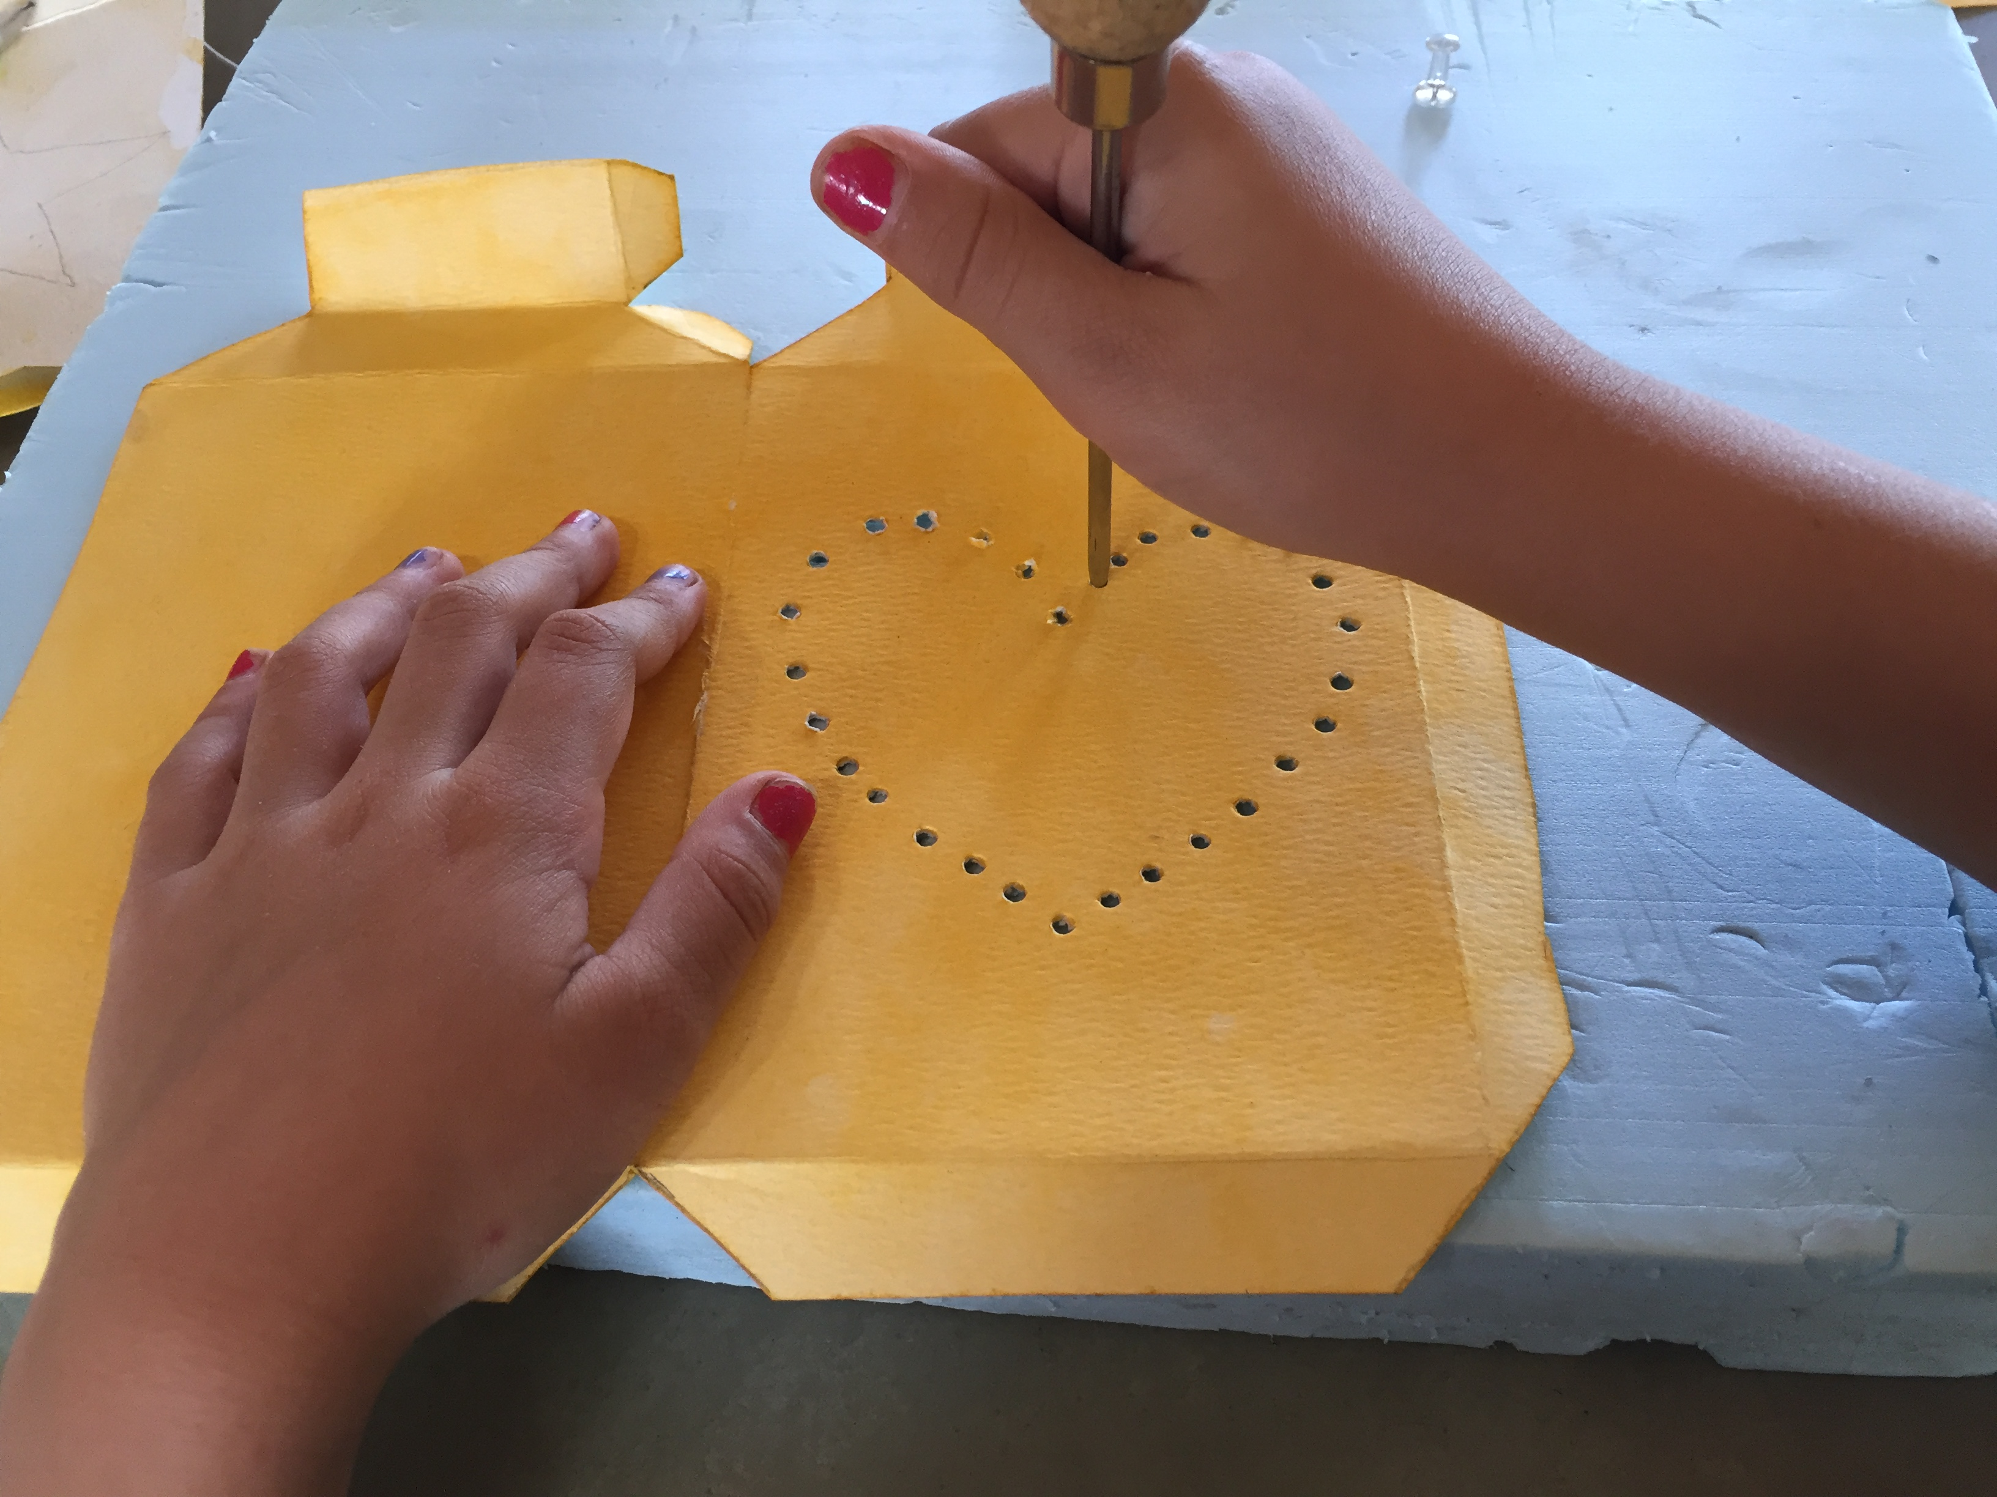

After all edges are folded and all holes are punched, start to glue each flap to its corresponding/adjoining side. Start from one of the long vertical sides. I found that a hot glue gun is by far the easiest way to do this.
First start gluing the two long vertical flaps to the corresponding/adjoining sides.

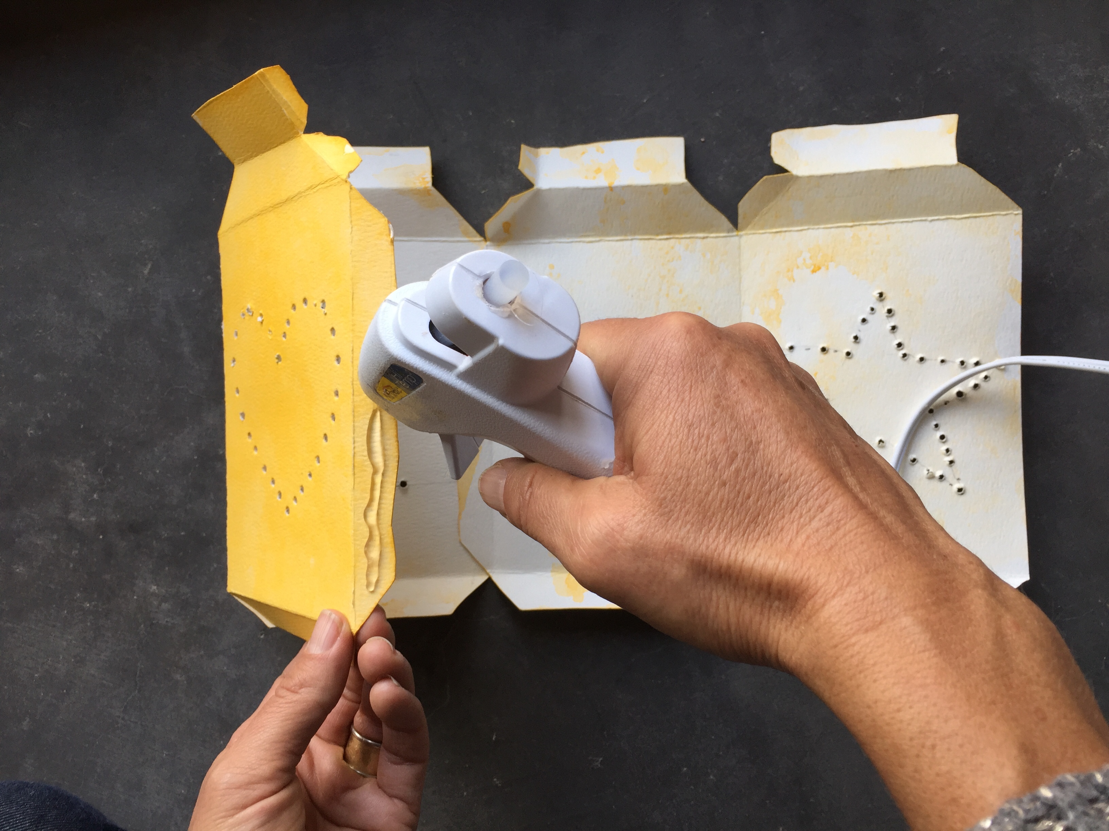

Now start gluing top flaps to their corresponding/adjoining top sides.
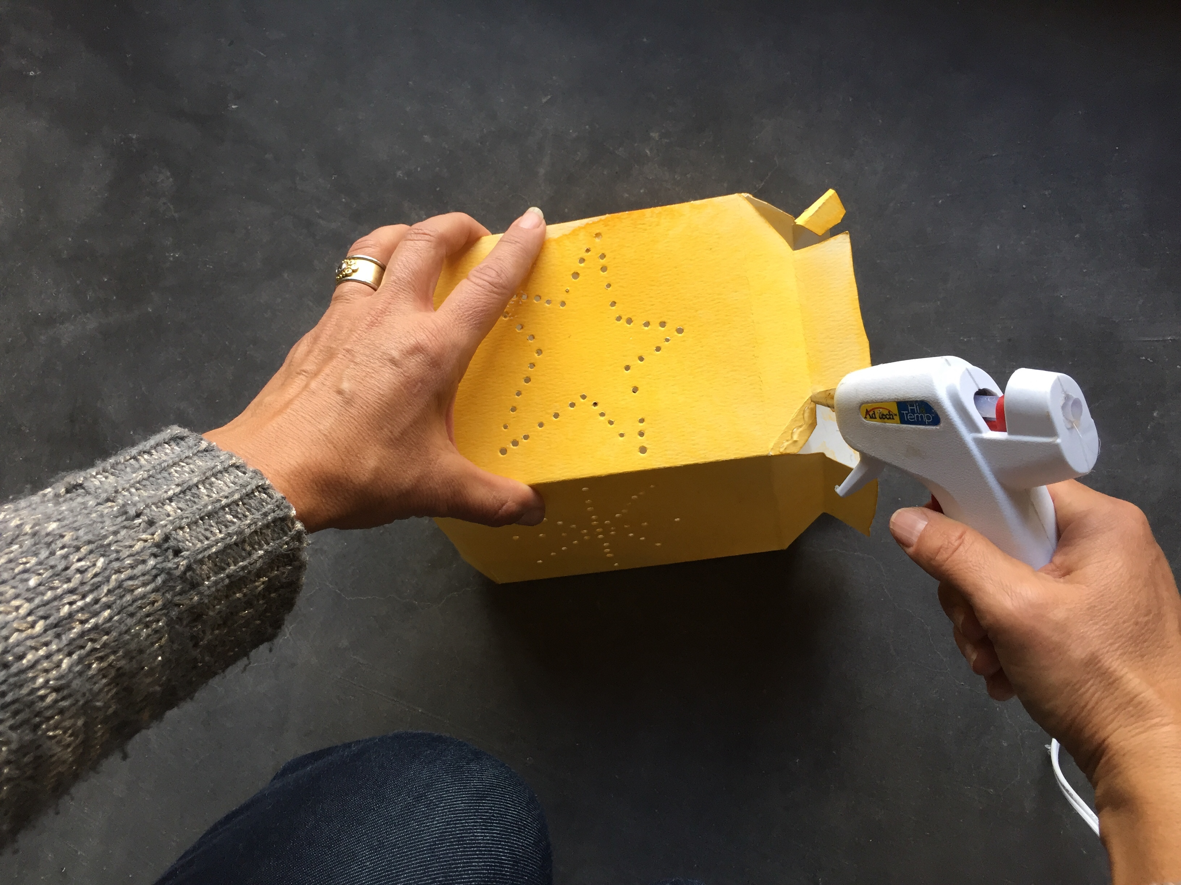

Glue the bottom flaps of the lantern onto the bottom square piece.
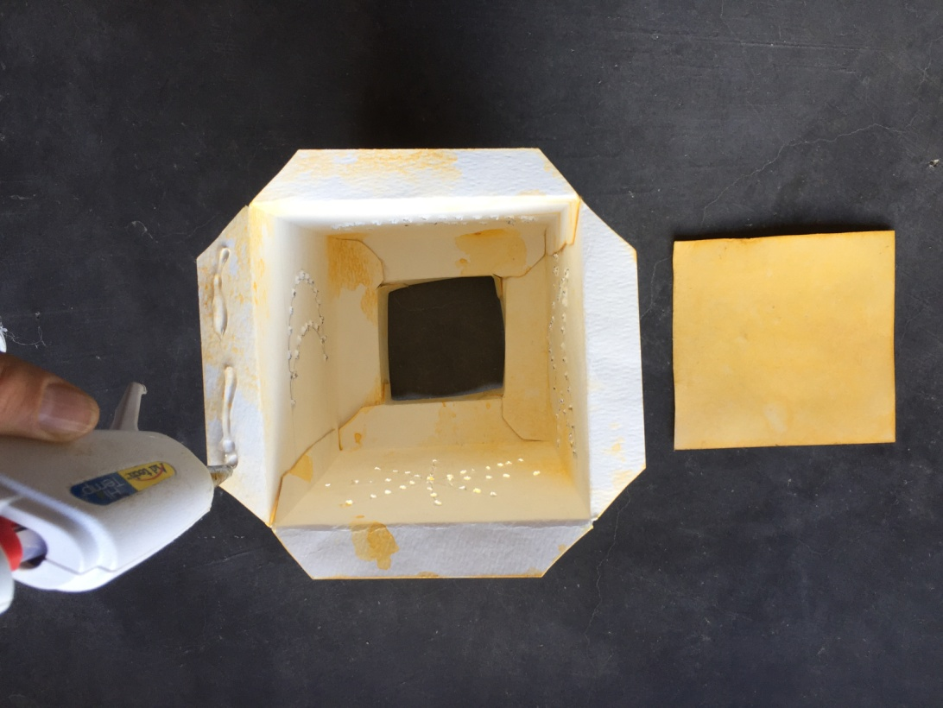

Finally, finish by gluing the handle flaps to the top of the lantern.
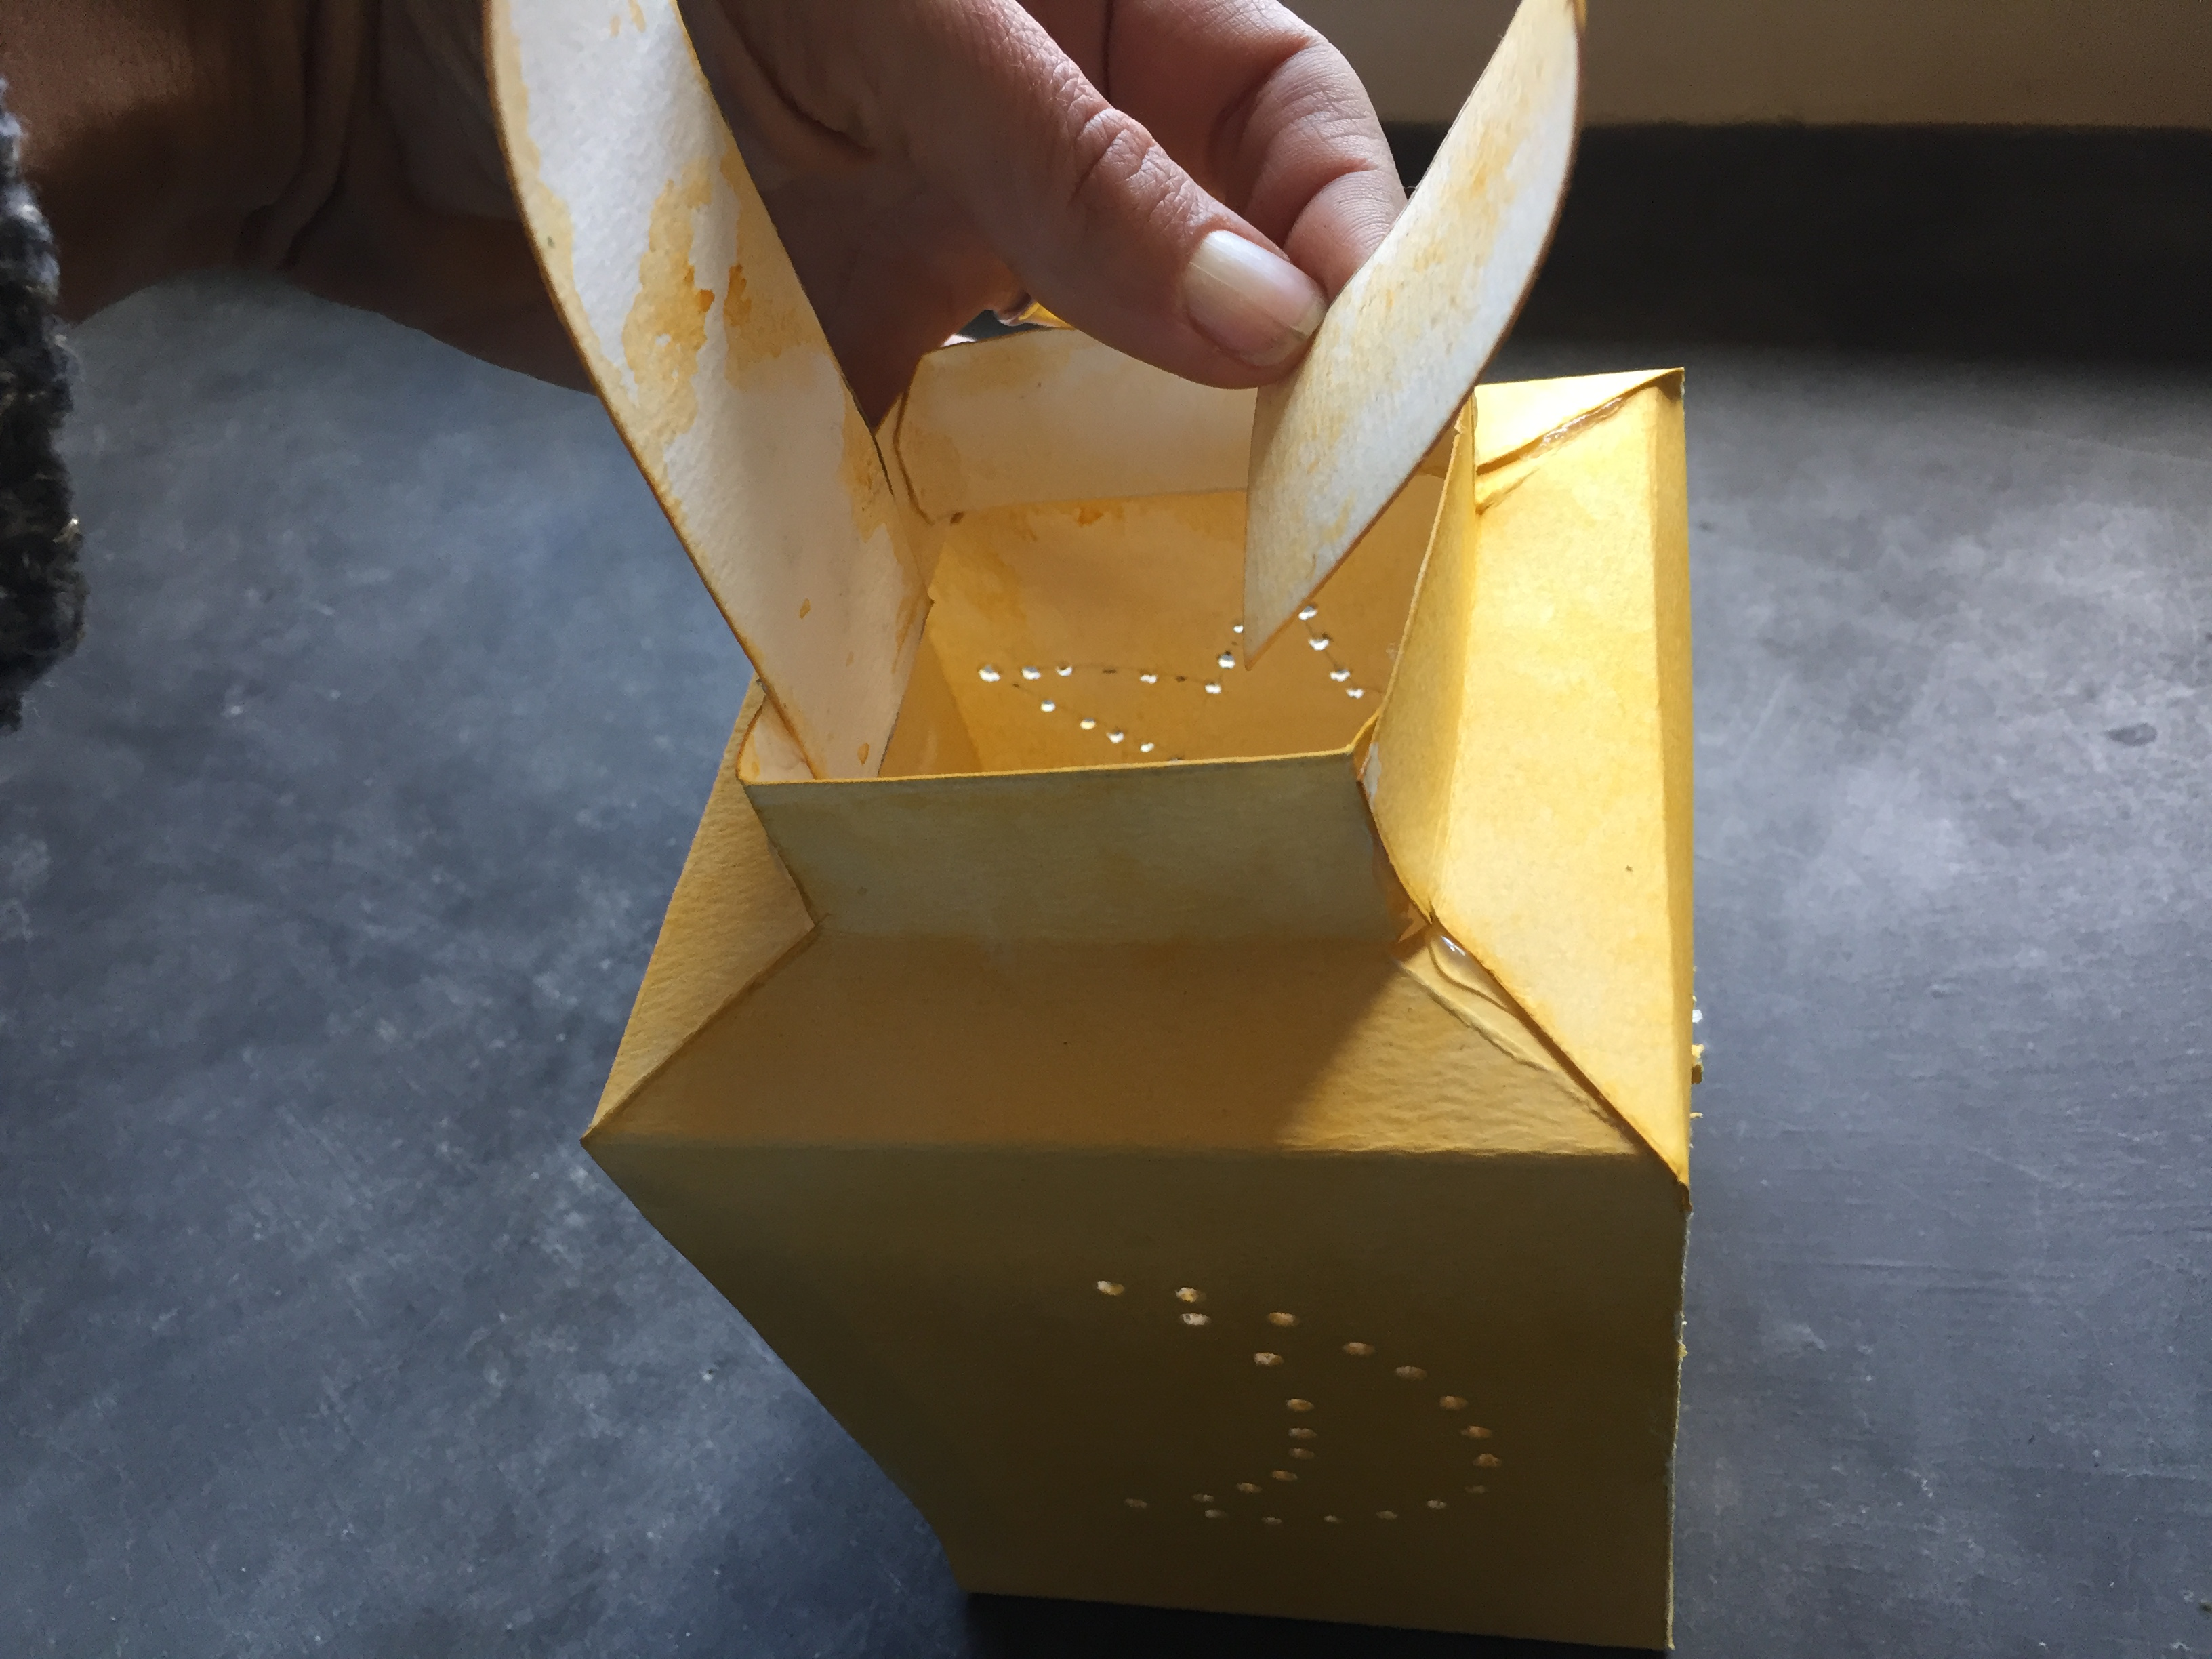

Place a candle in the bottom, and you have a beautiful lantern to carry through the night.
