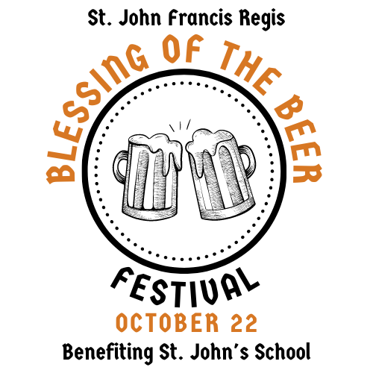

St. John Francis Regis Catholic Church
Blessing of the Beer Festival

Volunteer Guide

Event Rules / FAQs (1)
- EVENT TICKETS - Will be available for purchase online until midnight on Friday, Oct 21st. Tickets are available CASH ONLY at the event. There will be ATMs onsite; avoid the lines and bring cash to the event. Ticket sales are non-refundable.
    - Event Ticket: $35 - Includes 4 tasting tickets and a souvenir tasting glass (plus a koozie for the first 500 tickets)
    - Non-Drinker Ticket: $15
    - 15 and under FREE, no ticket required
  - All attendees will receive a wristband upon entry.
  - Re-entry will be allowed with proof of a valid wristband.
  - All minors under 18 must be accompanied by an adult.

- DRINK & TASTING TICKETS - Are $1 dollar each for every 4 ounce pour. Combine 4 tickets for a full 16 ounce beer. Souvenir tasting glasses are provided with pour lines in 4 ounce increments up to 16 ounces. Additional tasting tickets can be purchased with CASH ONLY at the check-in tents and at the water tent. There will be ATMs onsite; avoid the lines and bring cash to the event.
  - 4 Ounce taste – 1 Ticket
  - Full beer – 4 Tickets
  - Bottled Water - Will be sold for $1 per bottle

Event Rules / FAQs (2)
- PARKING - Will be in the grass area on the opposite side of the church/school and will be accessed through the Sandy Bottom Road entry. Please follow signs and directions from parking attendants. If you arrive later in the day, be on the lookout for overflow parking signs. It is highly recommended to carpool if possible.
  - The festival is handicap accessible. Handicap parking is available in the main church parking lot. Please proceed through the festival grounds to reach the check-in table upon arrival.

- CHECK IN - Please visit the check in station first between the parking lot and the festival area. Everyone with a drinking ticket will have their ID checked, so please have your ID ready when checking in.

- ITEMS PERMITTED– Guests will be allowed to bring lawn chairs, blankets, personal umbrellas, and sealed bottled water.

- ITEMS NOT PERMITTED– Coolers, tents, beach umbrellas, outside alcohol, outside food (baby food and snacks for small children will be permitted), weapons, and illegal substances.

- BAG CHECK – Bags are subject to search by event security at any time during the event.

- NO PETS – Only service animals allowed.
Event Rules / FAQs (3)
- BEER BLESSING – A blessing will be prayed over all in attendance approximately 12:30 pm at the Music Tent.

- MASS – All are welcome to join us for the 5 pm Mass in the Sanctuary. If you are a practicing Catholic and you plan to receive Our Lord in the Blessed Sacrament, please ensure you are in the proper state to receive Holy Communion.

- LAST CALL - Beer Samples End at 5:30 pm.

- KIDS ACTIVITIES – A kids area will be available and staffed by middle school volunteers. Please keep your children under supervision at all times.

- SEATING – Limited tables and chairs will be available around the festival. It is highly encouraged to bring your own lawn chairs and blankets to enjoy the festivities.

- BROKEN GLASSES – Please be very careful with your glass! If you require a replacement, there will be a fee of $5 (while supplies last). Please go to the water table for assistance.

- SMOKING - There will be no smoking or vaping allowed on festival grounds during the event.

- FIRST AID – There will be a First Aid station available near the food vendors.

- WEATHER– The event is rain or shine!
Event Rules / FAQs (4)
- DRINK RESPONSIBLY– Everyone 21+ must have a valid bracelet in order to drink. Please drink responsibly. Beer servers will not be permitted to serve any intoxicated guests.

- QUESTIONS – Our volunteer team will be ready to assist guests. Any questions prior to the event can be directed to blessingofthebeer@gmail.com
DON'T DRINK AND DRIVE
It is our responsibility to ensure that all of our patrons are served safely. We ask that you enjoy this festival responsibly.
Consider scheduling a safe ride home from the 2022 Blessing of the Beer Festival or using a ride-hailing service like Lyft and Uber.

Guidelines for ID Checks
- Remove ID – Patron must remove their ID from their wallet.

- Bend Test – Slightly bend the ID to ensure it recovers its original shape. Fake IDs may not pass this test.

- Picture Check – Ensure photo on ID matches the patron.

- Date of Birth – Ensure date of birth is prior to Oct. 23, 2001

